AS-IS Process

* Level 1 – AS-IS Claim Process

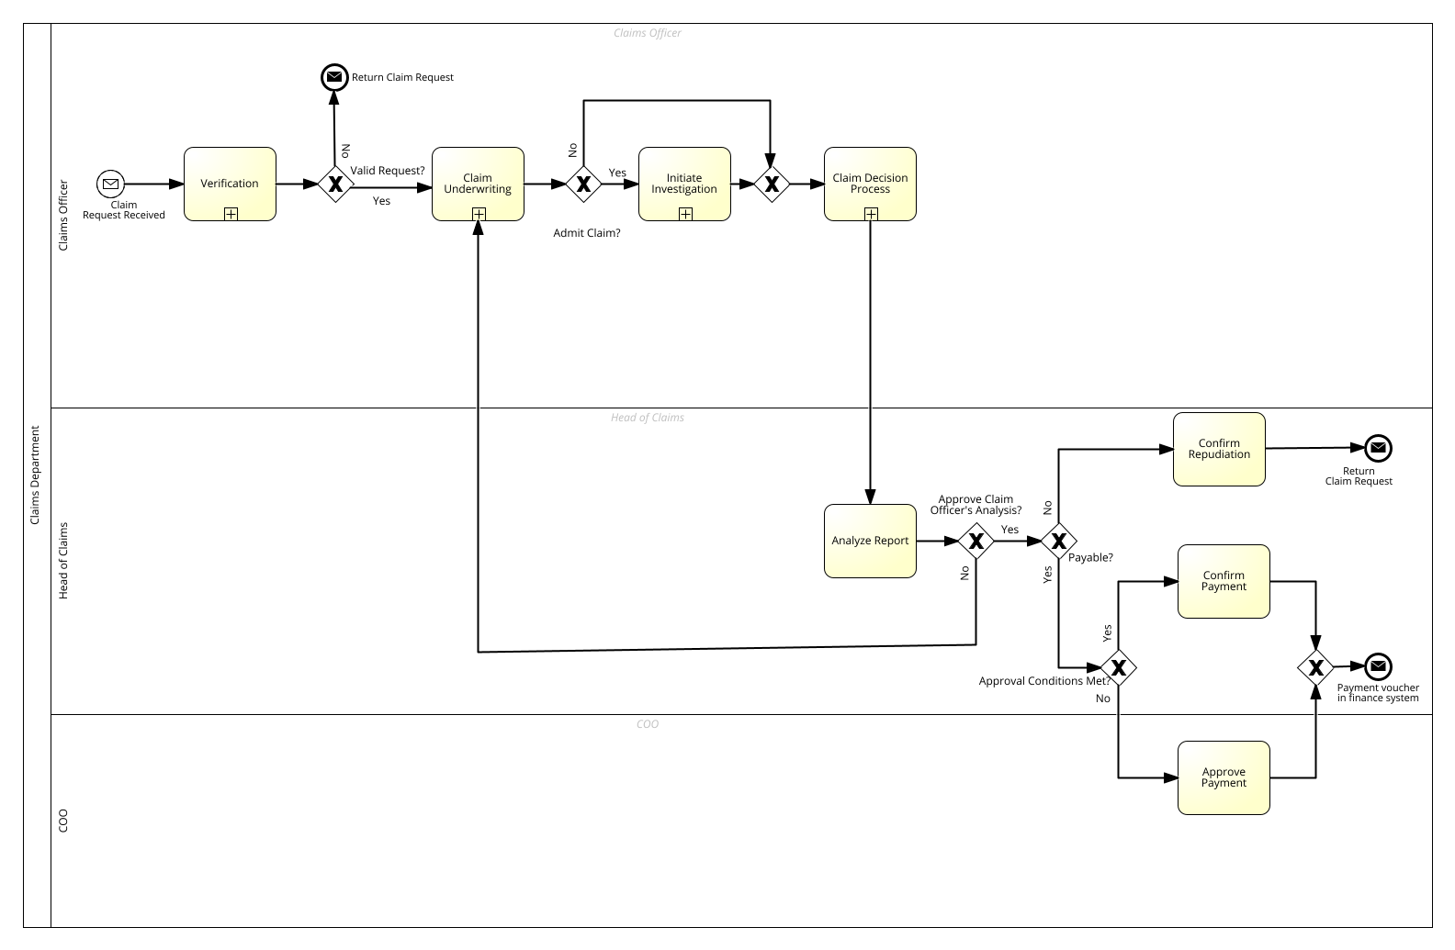

* Level 2 – Verification Sub-Process

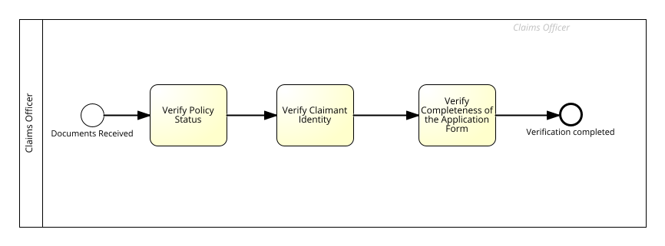

* Level 2 – Claim Underwriting Sub-Process

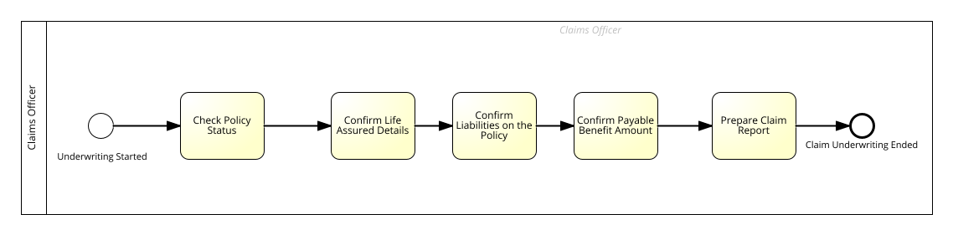

* Level 2 – Investigation Sub-Process

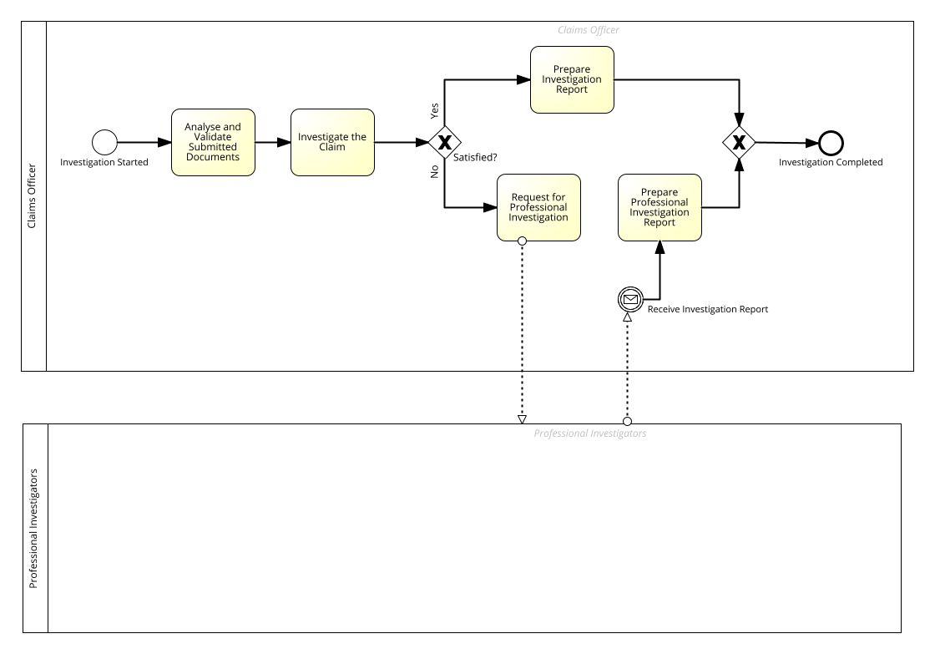

* Level 2 – Claim Decision Sub-Process

